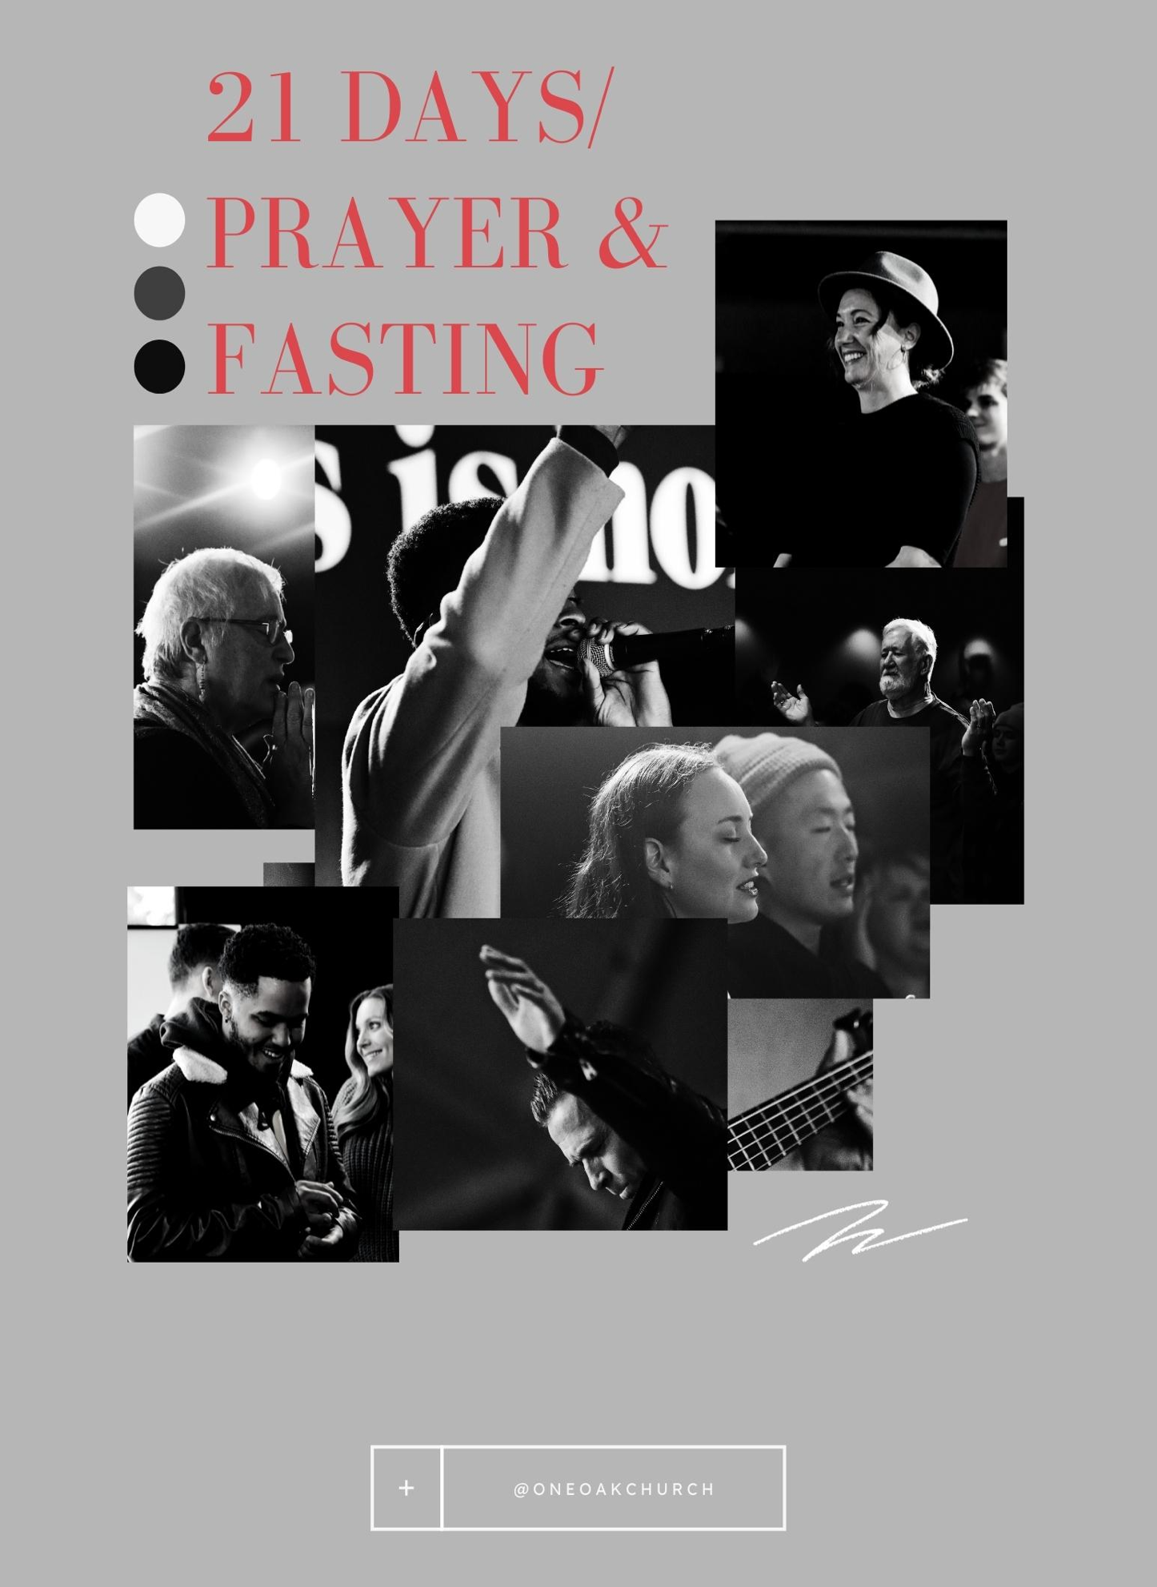

DEAR FRIEND
Each year, we intentionally set apart the month of January to minister and prepare believers for the new year. While all of us celebrate the start of a new year in January by creating some positive habits.
In this Devotional Guide, you will find levels of challenge.
Maybe you are new to walking in your Christian faith and are seeking to define the parameters of “what does it mean to be a Christ follower?” Each topic is an element of discipleship.
Maybe you are stuck in an area of life, or you realize that your relationship with God has become stale, and you want to know “how do I get back to the love and excitement I once had?”
Maybe you have been around for a while and want to know “why do we believe that is important to our faith?” You are encouraged to spend time in the Bible looking up the references and making notes.
Maybe you have heard it all before and need to be reminded “so you can give an answer for what you believe.”
Wherever you are on your journey and whatever you are facing, we want to invite you to begin again. Refresh your heart and life with Jesus. Perhaps some days you have more time to spend than others. Whatever level, for the next 21 days, you are encouraged to make it a priority to set aside some time every day to devote to your spiritual life.
We will be on the journey with you! If you have any questions along the way or need support, please email us at info@oneoakchurch.com
Pastor Robby Emery

HOW TO USE THIS DEVOTIONAL GUIDE:
In this guide, we will walk beside you as a friend or mentor, asking the hard questions in love, explaining the meaning of scripture, demonstrating how to pray, and jumpstarting your conversations with the Holy Spirit. It is our goal, our prayer, that at the end of this 21 days you will know His Word and know His Voice and love them both so much that you will embrace these disciplines for the rest of your life.
Section 1: Scripture Focus
The Scripture reading are passages of Scripture that we want you to study. You will notice that we only reference the passage and do not include it. That is because we encourage you to open a physical Bible, preferably not an electronic form, and read the text. Once you have read the passage, re read it a second time and use a high-lighter or pen to underline key words that standout to you in the text. You may even want to copy the passages that stand out to you in a notebook or journal and reflect on the meaning in your own words.
(Recommended Time: 5-10 minutes)
Section 2: Devotional Thought
The second section is time for connection with your true Teacher and Counselor, the Holy Spirit. Head to our Instagram and Facebook to watch one of our Team Leaders break the devotional for the day. (Recommended Time: 2 -5 minutes)
Section 3: Prayer Notes

The final section is the place for you to take notes from your conversation. When you ask questions, you will hear thoughts that you will think, oh, that is just me. No, that is Him speaking words of wisdom. You may use the space provided or your own journal or on your phone apps. Show Him how much you value His words by writing them down.
(Recommended Time: 5-10 minutes)

When using this devotional, it can take as little as 15 minutes and as long as 30-40 minutes. We encourage you to do what you can. Create disciplines that grow your spirit. Start the conversation in the morning and continue throughout the day and make notes before you go to sleep. Everyone has a unique relationship with God, and He cherishes the time He spends with each of us. Make this devotional experience an experience for you and Him to grow in rapport and make memories.
“But grow in the grace and knowledge of our Lord and Savior Jesus Christ.
To him be glory both now and forever!” II Peter 3:18

RESET
Day 1 Monday, January 10th
Scripture Focus:
2 Corinthians5:17
Prayer Starter:
• Holy Spirit, I long for those times of closeness when I felt Your presence. I confess I have allowed life to separate me from You. Highlight where my eyes, my mind, my time, my heart has turned from You?”

REFOCUS
Day 2 Tuesday, January 11th
Scripture Focus:
Hebrews 12:1-2; Luke 10:40-42; Ephesians 1:17-19
Prayer Starter:
• Holy Spirit, would You open my eyes to see the “great cloud of witnesses” to increase my faith? Is there anyone in my family who is part of the great cloud of witnesses?
• Holy Spirit, is there a wound in my soul that You are highlighting in this season that is causing a distraction?
• Holy Spirit, open the eyes of my heart to see Jesus as my One and Only.”

REMIND
Day 3 Wednesday, January 12th
Scripture Focus:
I Corinthians 15:1-4, 54-55; Romans 3:23; John 1:12
Prayer Starter:
• Holy Spirit, I confess my mind is overwhelmed that Jesus would do that for me. A part of me believes that salvation can’t be that easy. I repent, I turn away from wrong thinking, that I must work for my salvation.
• May wisdom and revelation open the eyes of my heart (Eph.1:17) to truly understand Jesus’s love for me and fully accept the good news of the gospel.
• Jesus, as I think about your love and sacrifice for me, I would like to take this time to express my gratitude.”

REPENT
Day 4 Thursday, January 13th
Scripture Focus:
Matthew 4:17; Psalm 139:24; Psalm 51
Prayer Starter:
• Holy Spirit, I ask, “Search me and know my heart. Examine me and know my anxious thoughts. Show me the offensive ways in me that I may quickly turn from them” (Psa. 139:24). (If He shows you something?)

RECOMMIT TO GOD
Day 5 Friday, January 14th
Scripture Focus:
I Kings 8:61; Psalm 37:5; I Timothy 4:7-8
Prayer Starter:
• Holy Spirit, with You as my accountability partner, I am ready to commit. I want a thriving relationship with You.
• What are the areas of my life that I need to recommit?

RESTRUCTURE TIME
Day 6 Saturday, January 15
Scripture Focus:
Proverbs 6:6-11; Ephesians 5:15-16; I Corinthians 10:23; James 1:5
Prayer Starter:
• Holy Spirit, where in my life am I wasting time?”
• What good works have you created for me to do today?
• Holy Spirit, are there “permissible but not profitable” things in my life?
• How can I balance my schedule to make an appointment time with you?

RETURN WITH FASTING
Day 7 Sunday, January 16
Scripture Focus:
Isaiah 58; Matthew 6:16; I Corinthians 12:9
Prayer Starter:
• Holy Spirit, I see that Jesus encouraged me to fast to grow stronger spiritually. I ask for You to show me what day and what meal to fast?
• What is my long-term plan? What should I do while I am missing my meal?
• What should be the purpose of my fast for this season?

RELATE WITH PRAYER
Day 8 Monday, January 17
Scripture Focus:
James 5:16; Song of Songs 2:14
Prayer Starter:
• Holy Spirit, I come to spend time with You. I purposefully clear my mind of everything but You. I quieten my soul like David in Psalm 131:1-2. I want to hear from You. I present the eyes and ears of my heart to you. I open my ears to hear Your voice. I open my eyes to see Your face. I open my heart to receive Your love. What would You like to say to me about (present the topic, question, scripture)?
• How can I pray for the will of Heaven to come to earth today?”

REFRESH WITH THE WORD
Day 9 Tuesday, January 18th
Scripture Focus:
I Chronicles 22:19; Proverbs 3:3-6; Psalm 119
Prayer Starter:
• Holy Spirit, let the Word of God speak, as I read/pray Proverbs 3:3-6, what fresh revelation would you like me to see?
• How am I to respond? What do you want me to see about you?”

REPAY WHAT IS GOD’S
Day 10 Wednesday, January 19th
Scripture Focus:
Malachi 3:10-12; Matthew 6:21; I Timothy 6:17-21
Prayer Starter:
• Holy Spirit, would You bring correction to my mindset about money and show me how it reveals the treasure in my heart?
• Where are doors that have been opened to the devourer in my life, especially with my finances?
• I want to demonstrate that You are first in my life in all areas. Today, I make a commitment to the spiritual discipline to cheerful giving of my money in the reoccurring amount of.”
RESPOND TO NEEDS
Day 11 Thursday, January 20th
Scripture Focus:
Matthew 25:40; James 1:12; Isaiah 1:17; Romans 12:11-13
Prayer Starter:
• Holy Spirit, I never want to take for granted the gift of my salvation. I repent forever thinking that I am better than the poor and ungrateful that are among us. I appreciate all that you have so generously blessed me with.
• Holy Spirit, show me someone in need today that I can share with an “act of kindness” to demonstrate Your love.”

REFRAME OUR WORDS
Day 12 Friday, January 21st
Scripture Focus:
Proverbs 18:21; Ephesians 4:29; Matthew 12:36; James 1:26
Prayer Starter:
• Holy Spirit, I repent for the words of my mouth that are not pleasing to You. I recognize that my heart is tempted to sin and in the moments of frustration and stress I don’t represent You well. I ask, forgive me and let Your water wash over my soul and bring refreshing and make me clean and whole.

RELEASE OFFENSES
Day 13 Saturday, January 22nd
Scripture Focus:
Matthew 6:14,15; 18:21,22; Mark 11:25; Ephesians 4:32
Prayer Starter:
• Holy Spirit, I am tired of hiding behind the excuses and resentment. I confess, I am offended and hurt by.” (Follow the steps above with the grace and tenderness of the Holy Spirit as your helper.)

RELY ON GOD
Day 14 Sunday, January 23rd
Scripture Focus:
Luke 8:22-25; Hebrews 11 1-3; Genesis 15:6; I Samuel 2:9
Prayer Starter:
• Holy Spirit, would You increase my faith?
• Would you show me where my faith is weak?

REFINE LIFE
Day 15 Monday, January 24th
Scripture Focus:
1 Peter 1:13-16; Zechariah 13:9
Prayer Starter:
• “Holy Spirit, I see that being holy like you are holy should be at the center of my life. What are past trials and tests in my life that I didn’t understand at the time that were producing gold (new character traits) or silver (redeeming forgiveness) in my life?”

REKINDLE LOVE
Day 16 Tuesday, January 25th
Scripture Focus:
Revelations 2:1-7; Matthew 24:12-13; Romans 8:16
Prayer Starter:
• Holy Spirit, what are the habits of grace that I should return to doing?

REVERE GOD
Day 17 Wednesday, January 26
Scripture Focus:
Proverbs 1:7; Proverbs 29:25; Hebrews 13:6
Prayer Starter:
• Holy Spirit, I ask to show me any area of my life where I am struggling with “fear of man’s opinion?” I want to reset that area back to a Fear of the Lord to bring me wisdom.
• I see that. I confess and repent.
• Holy Spirit, what is the truth of this fear? Can I t really hurt me? What is the worst thing that can happen to me?
• Holy Spirit, how should I respond in courage? What are you asking me to do? I want to represent You and Your Kingdom well.

RESIST TEMPTATION
Day 18 Thursday, January 27th
Scripture Focus:
I Peter 5: 8; James 4:7; Ephesians 6:10-17
Prayer Starter:
• Holy Spirit, I recognize I am tempted to sin by. In this quiet time, when it is just You and me, shine Your light.
• Holy Spirit, help me create a plan to with stand when the enemy comes with this temptation.
• I am ready to be strong in the spirit, whole in my heart and free in my soul.
REALIGN IDENTITY
Day 19 Friday, January 28th
Scripture Focus:
Ephesians 1:3-14; 2 Corinthians 10:3-5
Prayer Starter:
• Holy Spirit, do I have false beliefs about my identity? I ask for the word of God to be my mirror.

THE LIE
I am rejected. –––––––––––––––––––––––
I am guilty. ––––––––––––––––––––––––––
I am in adequate. ––––––––––––––––––––
I am a fearful, anxious person. ––––––––––
I am not very smart. ––––––––––––––––––
I am in bondage. –––––––––––––––––––––
I am unlovable/unloved. –––––––––––––––
I am unwanted. ––––––––––––––––––––––
I am hopeless. –––––––––––––––––––––––
I have no strength. –––––––––––––––––––
I feel condemned. ––––––––––––––––––––
I am alone/feel alone. –––––––––––––––––
I have no one to take care of me. ––––––––
There is nothing special about me. –––––––
I am not good enough. ––––––––––––––––
I am defeated. –––––––––––––––––––––––
I am afraid of Satan. ––––––––––––––––––
I can’t reach God. ––––––––––––––––––––
THE TRUTH
I am accepted.
(Eph 1:6; Ps 139:17)
I am totally forgiven.
(Eph 1:7; Ps 103:3; Heb 10:17)
I am adequate.
(Phil 1:7; 2 Cor 3:5)
I am free from fear.
(2 Tim 1:7; I John 4:18)
I have God’s wisdom.
(I Cor 1:30; Col 2:3)
I am free.
(2 Cor 3:17; John 8:36)
I am very loved.
(John 15:9; Eph 2:4-5)
I have been adopted by God.
(I John 3:1; Rom 8:16-17)
I have all the hope I need.
(Rom 15:13; Ps 31:24)
I have God’s power.
(Eph 1:1; Eph 3:20)
I am blameless.
(Rom 8:1; John 3:18)
I am never alone.
(Heb 13:5-6; Rom 8:38-39)
I am protected/safe.
(Ps 32:7-8; 10-11)
I have been chosen by God.
(I Cor 6:11; I Peter 2:9-10)
I am perfected in Christ.
(Heb 10:14; Col 2:9-10)
I am victorious.
(2 Cor 2:14; Rom 8:37)
I have authority over Satan.
(Luke 10:19; I John 4:4; I John 3:8)
I have access to God.
(Heb 10:19-22;Eph 3:12)
RECONNECT TO THE GREAT COMMANDMENT
Day 20 Saturday, January 29th
Scripture Focus:
Luke 10:25-37; Matthew 22:36-40; Mark 12:28-34; I Corinthians 13
Prayer Starter:
• Holy Spirit, what is the clutter in my life that fills my mind, my affections, my soul, my strength instead of God?

REJOIN THE GREAT COMMISSION
Day 21 Sunday, January 30th
Scripture Focus:
Matthew 9:37-38, 28:18-20; Mark 16:15; Luke 24:46-47; John 20:21; Acts 1:8
Prayer Starter:
• Holy Spirit, open my eyes and ears to see what you see and hear what you hear. As I look around my world today with You, can You highlight who needs a word, a prayer, to be heard today?
• Holy Spirit, how am I doing loving my family?
• Am I discipling well at home?
• How can I keep this attitude of prayer, with me, through the rest of the year?

ONEOAKCHURCH.COM

